EXPERIMENT:1
DATE:14.07.26

8-Puzzle Problem using Breadth-First Search (BFS)

Aim
To write a Python program to solve the 8-Puzzle Problem using the Breadth-First Search (BFS) algorithm.
Algorithm
- Define the initial state and the goal state.
- Create a queue and insert the initial state into it.
- Mark the initial state as visited.
- Remove the first state from the queue.
- If it matches the goal state, stop the search.
- Otherwise, generate all possible next states by moving the blank tile (up, down, left, and right).
- Add all unvisited valid states to the queue.
- Repeat the process until the goal state is reached.
- Display the sequence of moves and the goal state.
Program
from collections import deque
goal = [
[1,2,3],
[4,5,6],
[7,8,0]
]
moves = [(-1,0),(1,0),(0,-1),(0,1)]
def find_blank(state):
for i in range(3):
for j in range(3):
if state[i][j]==0:
return i,j
def state_tuple(state):
return tuple(tuple(row) for row in state)
def bfs(start):
queue=deque([(start,[start])])
visited={state_tuple(start)}
while queue:
state,path=queue.popleft()
if state==goal:
return path
x,y=find_blank(state)
for dx,dy in moves:
nx,ny=x+dx,y+dy
if 0<=nx<3 and 0<=ny<3:
new=[row[:] for row in state]
new[x][y],new[nx][ny]=new[nx][ny],new[x][y]
if state_tuple(new) not in visited:
visited.add(state_tuple(new))
queue.append((new,path+[new]))
print("Enter Initial State (use 0 for blank):")
start=[]
for i in range(3):
start.append(list(map(int,input().split())))
solution=bfs(start)
print("\nGoal State\n")
for row in goal:
print(*row)
print("\nSolution Path\n")
for step in solution:
for row in step:
print(*row)
print()
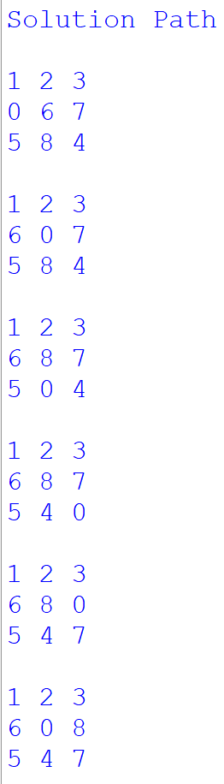
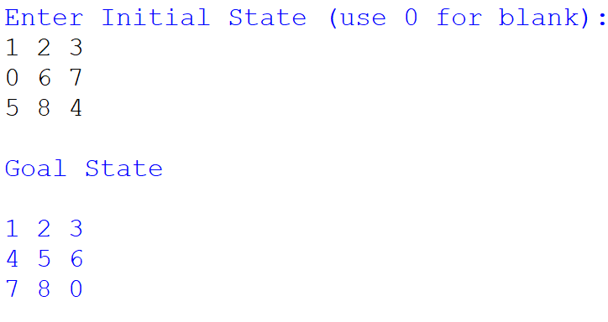
Output
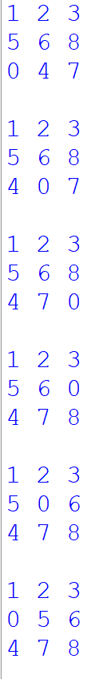
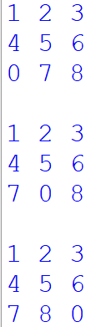
Result
Thus, the Python program to solve the 8-Puzzle Problem using the Breadth-First Search (BFS) algorithm was successfully executed, and the goal state was reached.

